SQL Server Connectivity Troubleshooting

ERROR: Cannot connect to SQL Server <SQL Server Name provided in configuration>
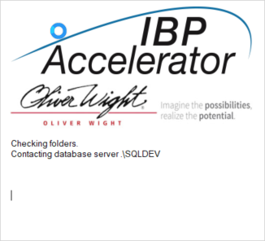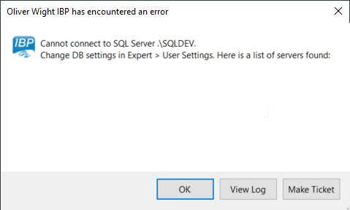
- SQL Database Server Name correct?
  - Check SQL Database Server Name is correct. Sometimes it’s just as simple as a misspelling. i.e. The above screenshot shows the Server Name as SQLDEV but actually it is SQL16DEV. Once corrected, connection to SQL Server was successful.
- Can user connect to database?
  - Test user credentials and connectivity by creating an ODBC connection.
    - Open ODBC Data Source Administrator (Start > Windows Administrative Tools > ODBC Data Sources)
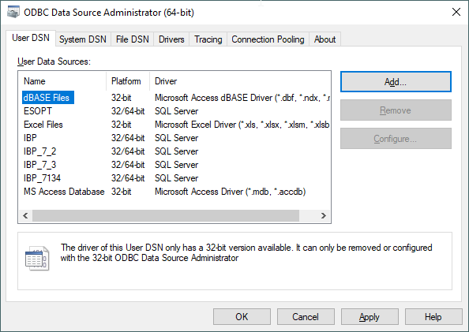
    - Add a New Data Source, click Add, and then select the driver that is associated to your SQL Server, and click Finish. In this example I am using SQL Server driver version 10.00.18362.01
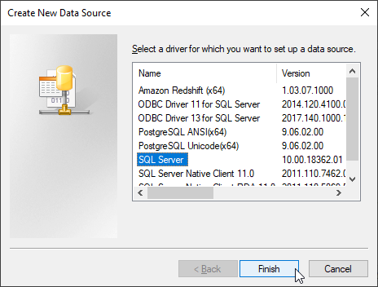
    - Then create a new data source to SQL Server driver, enter the Name to reference this data source, i.e. IBP. Then enter Description, i.e. IBP database. And enter the Server that you want to connect to.
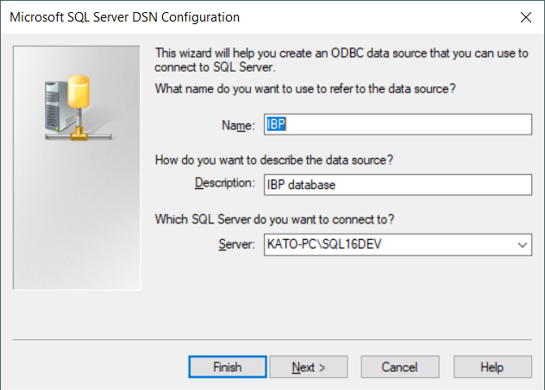
    - Click Next, select Windows NT to authenticate
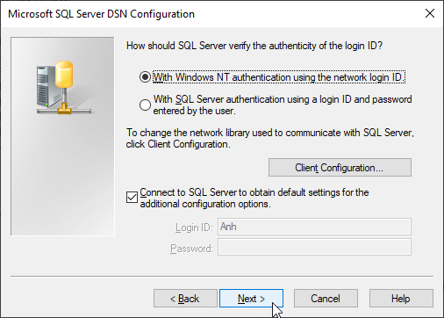
    - Click Next, change the default database, select the database for IBP Accelerator, i.e IBP
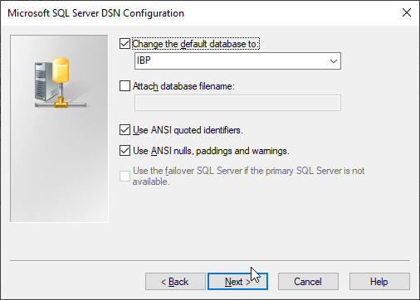
    - Click Next and Finish.
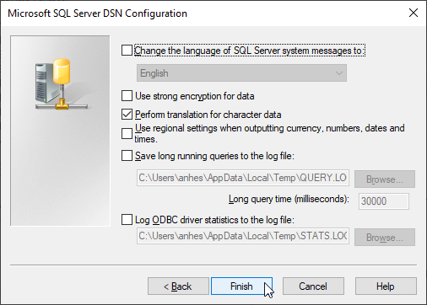
    - Test Data Source Connection.
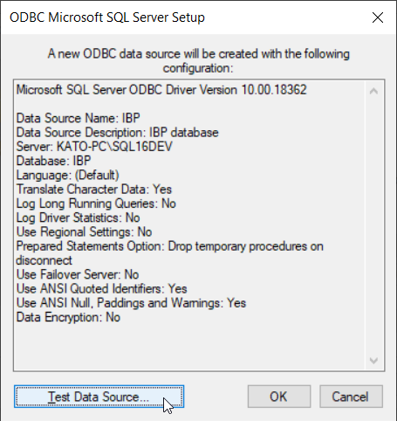
**If the connection works, this shows that user can connect to SQL Server from this computer, and therefore IBP-A should be able to as well. If connection does not work, check user access to database (i.e. check active directory group to see if user is added to the group that has IBP database access)
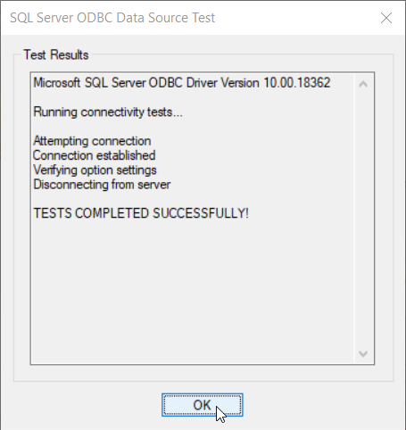
- Network Connectivity.
  - If SQL Server is on a different machine (i.e. server), can you ping that machine from the client?
    - Start > Run > CMD, then type ping DBSQLServerName.
    - If server is not reachable, try to ping with IP address instead of DBSQLServerName
      - If IP address works and server name does not, use IP address instead of DBSQLServerName in the config file (C:\Program Files\IBPAccelerator\ IBPAccelerator.exe.config)

<setting name="DBSQLServerName" serializeAs="String">
<value>.\SQL16DEV</value>

      - or in IBP-A, Expert > User Settings > DBSQLServerName
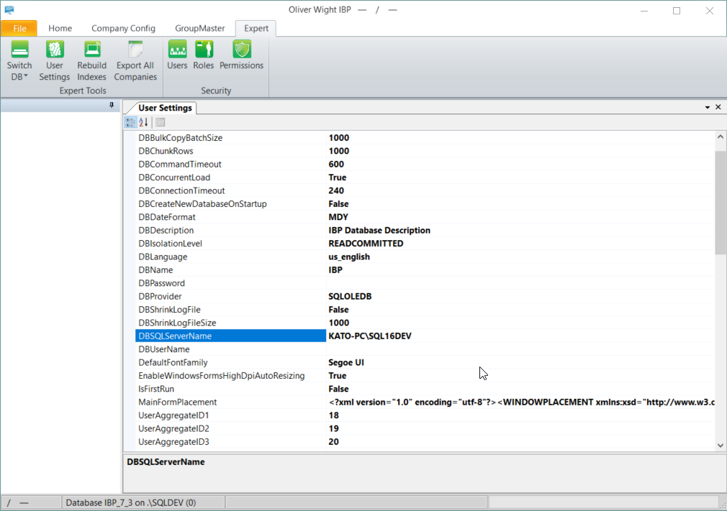
    - If ping does not respond, this suggests a network connection problem.

If the problem persists, contact IBP-A Support – support@oliverwight.com

